**Hotel Management System**

Design Documents

**Introduction**

The hotel management project aims to develop a web-based application to facilitate room management in a hotel. It will provide room management facilities like adding, updating and booking rooms. The application will have two primary users, the Admin User responsible for managing rooms, and the Customer, who can enquire about room availability and make bookings.

**Functional Specification**

**Requirements**

Hotel Management different actors:

**Admin User:**

Room Listing Page:

* Display a list of all available rooms using a jQuery Database.
* Include columns for Room Type, Price, and Action (Edit/Delete)

Add/Update Room:

* Provide a pop page to give add/update room details.
* Provide each field as below,

- Room Type (Dynamic Drop-Down bring data from DB table)

- Price

- Room Amenities

- AC/Non-AC (Radio Button)

- Smoking/Non-Smoking Room (Radio Button)

- WI-FI/TV/Geyser (Check Box)

Delete Room:

* Verify if the room has any outgoing or future bookings. If so, display an error message. Otherwise, delete the room.

**Customer**:

Enquiry about room availability.

**Technical Specification**

**Database Details**

Schema Name: hotelmanagement

**Tables**

1)RoomType

- roomTypeId (Primary Key, int)

- Room Type (varchar (200))

2)Rooms

- roomId (Primary Key, int)

- roomTypeId(Foreign key, int)

- isACAvailable(numeric (1))

- isSmokingAvailable(numeric (1))

- amenties(varchar (200))

3)BookingDetails

- bookingDetailsId(Primary Key, int)

- roomId( int)

- bookingDates(Date)

- customerName (varchar (200))

- customerEmail (varchar (200))

- customerMobile(varchar (200))

- desc

**Class Diagram**

**Entity classes**

Room class joining two table “RoomType” and “Rooms”

Room

- roomId : int

- roomTypeId : int

- roomType : String

- isACAvailable : boolean

- isSmokingAvailable :boolean

- amenties : Json

BookingDetails

- bookingDetailsId : int

- roomId : int

- bookingDates : Date

- customerName : String

- customerEmail : String

- customerMobile : String

**Controller**

HotelManagementController

+ getAllRoomDetails()

+ addOrUpdateRoom(Room room)

+ deleteRoom()

**Service and Repository**

HotelManagementService

+ getAllRoomDetails()

+ addOrUpdateRoom(Room room)

+ deleteRoom()

HotelManagementRepository

+ save(room : Room)

+ findById(roomId: room)

+ findByRoomAndDate(roomId : int, bookingDate : Date)

**UI Screen Model**

**Room Details Page** contain the details of roomlike Room Type (Superior/Deluxe/Luxury/Suite), Price, Action as below

Room Details

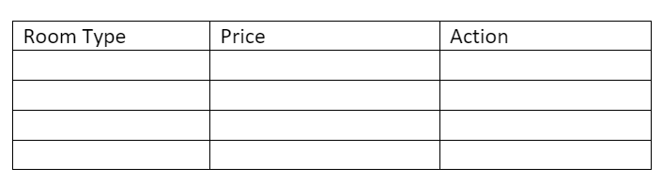

Edit/Delete

If click on the “Edit/Delete”, it will navigate to new page name it as **Booking Listing Page**

Search filter available for Booking Date and Room Type.

Booking Listing

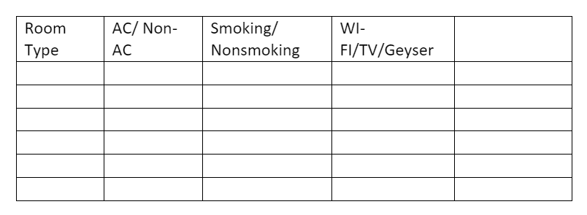

Booking date

Room Type

:

:

Add Room

**Technology Stack**

Java: Programming language for backend logic

Spring Boot: Framework for building the application’s business layer and RESTful APIs.

JSP: Templating engine for rendering dynamic web pages.

MySQL: Relational database management system for storing application data.